Rosemary Davis Environmental Series
Thayer Memorial Library

Creepy Crawly CRITTERS!

with Rae Griffiths of Teaching Creatures

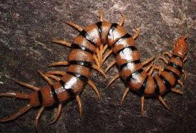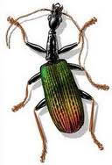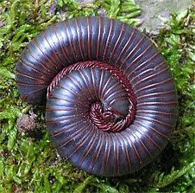

Tuesday, July 12 @ 1 pm

This program is supported by a grant from the Rosemary Davis Fund of the Greater Worcester Community Foundation.
Rosemary Davis was a Lancaster resident with a passionate concern for nature and the environment.

Lancaster residents are given priority seating.

