Puppy Dogs

Kitty Cats

Big Green Frogs

Wearing hats!

Green the color of spring

Plants sprout up to greet the sun

Wave hi in the wind

Our dog likes to bark.

On walks he leaves his mark.

He finds a step.

Uses some pep.

And once he’s home

He finds his zone.

And takes a giant rest.

**LEVI, WHAT DO YOU THINK ABOUT WHEN YOU THINK ABOUT SPRING?**

Flowers blooming

Some tulips

Some grass and a hill

Flowers blooming

The llama, some bears

Some mommies

Someone is outside

Someone said goodbye

Sea Weed. lazily

Floating on the ocean’s

Surface. Sea Weed.

Dancing on the water

like a ballerina. Sea Weed.

Otters use sea weed as a bed.

Sea Weed.

**(Haiku)**

I Love dinosaurs.

dinosaurs are so splendid.

I also like pigs.

Hi, I love you. ☺

Keep going!

Roses are red, Violets are

blue You are as kind

as a tree.

April is always a fun time

because of this I must rhyme,

the weather’s always sublime

every year around this time.

I gather each quarter penny and dime

I use this money to buy slime

and on April Fools it’s show time!

😝

once there was a baby otter

then he died

it was sad

but it actually wasn’t that sad

(2 drawings included on original)

The cardinal, the cardinal.

The rat is grey

The rat is green

The rat gobbles up cheese

he lives in a sewer

but that’s all right

because he fights off

the bats with all

his might. he eats

the mold he eats

the peas and gets the bugs off

trees

I wanted a cat so I could

play. My old cat sat down to

Lay. Please play play play.

But all he did is rest waiting

For the day kittens were play

ful and fun. I wanted one

One day he sat down to lay

His eyes closed his breath stopped

and then all I wanted was my

cat that lay.

I like to read books

They are so very darn good

I like to read books

–The End

I can’t seem to put it into words

But I care for you so much it hurts

Passion bright as a dragon’s flame

I hear the crickets sing your name

Like a river, deep, whispering, shimmering, bold

I feel it winding through my soul

**Memorys**

Memorys are light

Memorys are there

Memorys are gone

Memorys are best with people loved.

Memorys stay.

**Snow**

Snow jumps out from behind a cloud

Follows you wherever you go

You’re blocked in until it’s plowed

But when the plow comes it’s quite loud

Then you frolic in the snow

Snow jumps out from behind a cloud

Leaping through the snow look at me go

The days grow hotter

longing for a popsicle

brain freeze brings relief

There once was a bat from Plat,

Who owned a great feathered hat.

It dropped as he flew,

You could hear his boo hoo,

As it fell onto a voluptuous cat!

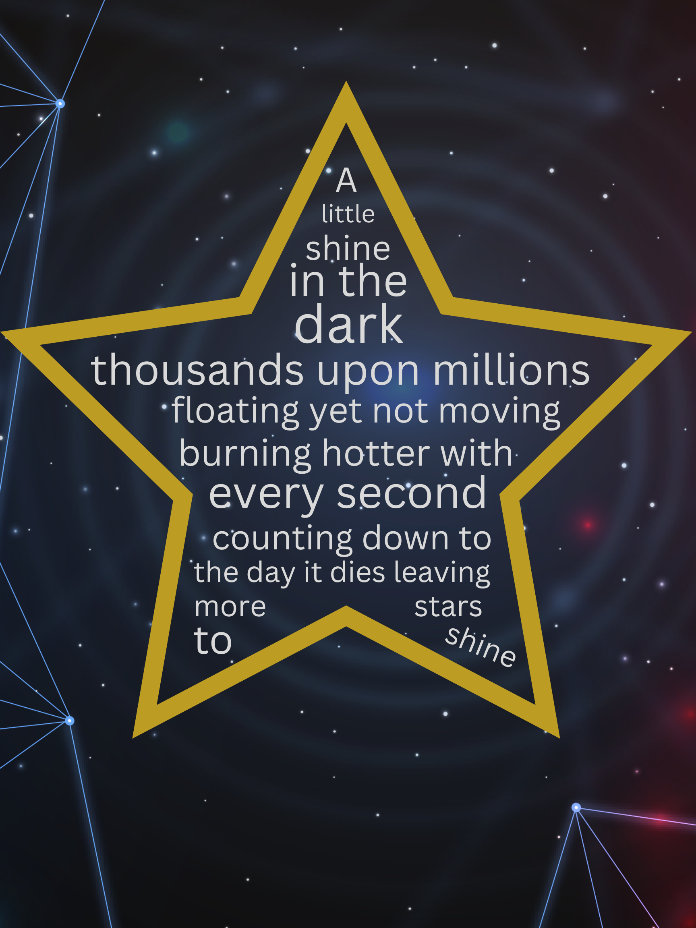

**A Wish In the Dark**

Born all alone in a Namwon Prison

Unfairly confined until age thirteen

A caring heart escapes under the sun

Guilt follows him as he floats down the stream.

A kind heart will take him in on the shore

In a monks robes and shaved head he is blessed

A confrontation will soon be in store

But he escapes again and makes Nok stressed.

Back to Chatana, his friend finds him

Given shelter by Ampai and her friends

Ready to march with light on Giants Bridge

Governor stops them, wanting it to end.

Sacrifices himself to save the town,

Even though there is a chance he might drown.

Books are wonderful,

They create an adventure,

Inside of your mind.

Tonight when you wake

Ask for help

Ask for the balm for the deep

Aches of your heart

Ask to be anointed with the sweet

Oil of your worth

Ask that you wear vestments that

Show all these who loved you

Ask for the sleep that holds you

in its embrace

Ask to walk through the gate

Into all the day brings

**Self Talk**

Deep breath in

Deep breath out

Today is a new day

All you have to do is believe in yourself

Because I believe in you

If only you could see just how amazing you are

You may think you are imperfect

You may thing you are flawed in so many ways

But everything that makes up you is what makes you perfect

I know you are going through a lot

I know it’s hard right now

I know you may not see the rainbow that comes after this storm

But it will get easier

You will get to do everything you want to do and accomplish in your life

It starts with getting out of bed and putting your feet on the floor

Inhale

Exhale

Today is a new day

It’s going to be okay.